Whistleblowing

A training workbook for staff

What is whistleblowing?

Whistleblowing is the term used when someone who works for an employer raises a concern about malpractice, risk (for example about service user safety), wrongdoing or possible illegality, which harms, or creates a risk of harm, to people who use the service, colleagues or the wider public.

This is known as making a disclosure in the public interest.

Expectations within our sector

The Social Care Code of Conduct sets out the expectations of adult social care workers. Guidance Statement 9 in the Code of Conduct’s first standard relates to accountability and states:

“report any actions or omissions by yourself or colleagues that you feel may compromise the safety or care of people who use health and care services and, if necessary use whistleblowing procedures to report any suspected wrongdoing”.

Our policy statement in relation to whistleblowing

We are committed to running the organisation in a way that meets all our legal obligations and ensures correct and proper practice. It is possible that at times that in order to do this, we may need your help.

Our whistleblowing policy is designed to ensure that we meet the requirements of the Public Interest Disclosure Act. That is to say that if you have genuine concerns about practice or occurrences relating to your employment by the organisation, if you raise these in good faith and in the correct manner, we will ensure that you are protected from any reprisals or unfair treatment as a consequence of raising your concerns.

By providing this assurance we would hope to encourage you to raise any concern you may have at an early stage.

We would want you to feel comfortable to raise any concern but particularly if it was a serious concern such as inappropriate or unlawful conduct, financial mismanagement or poor practice and behaviour.

What the law says (a summary)

Following a number of high profile events, the government introduced the Public Interest Disclosure Act 1998 (PIDA). This provides legal protection against reprisals for workers who raise concerns in the public interest (also known as making a disclosure) about a danger, risk, malpractice or wrongdoing in the workplace which affects others.

To be protected, the disclosure must be in the public interest, the worker must have a reasonable belief that the information shows that one of the categories of wrongdoing listed in the legislation has occurred or is likely to occur, and the concern must be raised in the correct way.

Who is protected by the Public Interest Disclosure Act?

The PIDA provides protection for people who can make protected disclosures. These people are:
- Workers who are directly employed by the registered provider.
- Workers who have left their job after making a protected disclosure.
- Other workers who provide services to the registered provider.

What is a ‘protected disclosure’?

To qualify as a ‘protected disclosure’ the disclosure must satisfy a number of requirements under the PIDA. These are:
1. The worker must have made a ‘qualifying disclosure’. This is a disclosure of information which, in the reasonable belief of the worker, tends to show one or more of the following:

a) That a criminal offence has been committed, is being committed, or is likely to be committed.

b) That a person has failed, is failing, or is likely to fail to comply with any legal obligation to which he is subject.

c) That a miscarriage of justice has occurred, is occurring, or is likely to occur.

d) That the health and safety of any individual has been, is being, or is likely to be endangered.

e) That the environment has been, is being, or is likely to be damaged.

f) That information tending to show any concerns relating to the above have been, or are likely to be deliberately concealed.
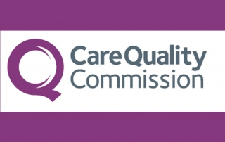

A disclosure of information is not a qualifying disclosure if the person making it commits a criminal offence in doing so.

2. The qualifying disclosure must be made ‘in good faith’. This means it must be made with honest intent and without malice. The worker must reasonably believe that the information is substantially true.

3. The worker must make the qualifying disclosure to one of a number of ‘specified persons’ set out in PIDA, which include:
a) The worker's employer or,
b) the relevant ‘prescribed body’.

What is a ‘prescribed body’?

A ‘prescribed body’ is an organisation that has regulatory authority and / or legal powers for a particular sector or area of responsibility and which is identified under the PIDA as able to receive concerns about organisations. In our case the prescribed body for any concerns relating to our services would be the Care Quality Commission.
Examples of concerns where you might feel the need to ‘whistle blow’

Examples of concerns where you might feel the need to ‘whistle blow’ include if you witness or suspect someone within the company of:

- Physical or emotional abuse or failing to treat people we support with respect and dignity
- Bullying or Harassment
- Abusing their power or position of authority
- Exhibiting attitudes that make you feel uncomfortable such as the use of racist, sexist or derogatory language
- Theft, fraud, bribery or any form of financial mismanagement
- Practicing in a way that compromises the Company’s commitment to Health & Safety.
- Wasting resources or energy in a way that prevents us meeting our environmental obligations.
- Being under the influence of alcohol or illegal drugs whilst on duty
- Persistently coming in late to work, nipping off early or leaving an unfair amount of work to others.

In situations such as these, you may not feel able to raise the issue with the person directly but neither do you feel comfortable with the way they are behaving and you think it is having a negative impact on your work place. Where this is the case, we want to create a safe environment for you to raise your concerns or to whistle blow.
Our assurance to you
We understand that it can be difficult for people to raise concerns. We are also aware that in the past, the management of organisations have often treated people as trouble-makers who have reported or alleged malpractice by colleagues.

However, staff are there on the ground and see and hear what is going on a day to day basis and are therefore well placed to raise concerns.

The Public Interest Disclosures Act 1998 prevents people from being treated detrimentally or having their contract terminated for ‘whistle blowing’.

If you act in good faith and raise what you believe is a genuine concern in the correct way, you will not be at risk of losing your job or suffering any form of reprisal as a result even if you are mistaken.

We will protect your anonymity where we can but it has to be recognised that this may not always be possible.
If it is not possible to protect your anonymity then we will work to support your future relationship with the person / people concerned so that they are clear that you have acted within the parameters of our whistle blowing policy and any form of reprisal against you could result in disciplinary action.

If you experience any bad treatment such as bullying or harassment because you have spoken up or raised a concern, let your manager know and ask to be protected in line with the Public Interest Disclosure Act.

We hope however that if you have genuine concerns, you will feel able to raise them. If you do have anxieties about the implications if you raise concerns, then please discuss them in confidence with your line manager or another senior manager and be clear about your anxieties.

Something to be aware of

If it is found after investigation that a staff member has raised an issue maliciously or which they know to be untrue, then this could result in them being subject to disciplinary action.

Whistleblowing: Top tips
The following tips are intended to support workers to follow a proper due process when raising whistleblowing concerns. These therefore represent our whistleblowing procedure.

N.B. It is very important that you follow the whistleblowing procedure correctly to ensure you are protected.

1: By showing your concern, can you resolve the issue straight away?

If you see an unsafe practice, risk or wrong doing, can you tackle it yourself, there and then, either by talking to the individual(s) concerned or raising the issue with a manager within the organisation?

Ask yourself whether you can raise your concerns informally initially and if by doing so you believe the issue will be listened to and resolved effectively.

Sometimes raising your concern in a polite but firm way may be all that is needed to resolve the issue.
2: Read the Whistleblowing Policy and Guidance Notes and follow the Whistleblowing Procedure

If you do not feel you can resolve the issue informally and straight away, then consult the whistleblowing policy and guidance notes and follow the procedure.

Collectively these documents tell you:
a) what type of concerns are covered
b) when and how a concern should be raised and who with.

You need to follow the guidance to make sure you remain protected under the law (The Public Interest Disclosure Act 1998) (PIDA).
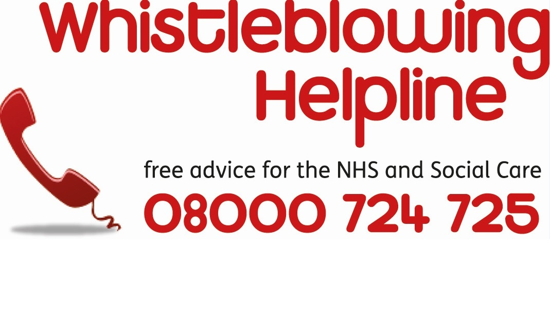
You can get free, confidential and independent advice at any stage from:

The National Whistleblowing Helpline,
Phone no: 08000 724 725
Website: www.wbhelpline.org.uk
or
Public Concern at Work
Phone no: 020 7404 6609
Website: www.pcaw.co.uk
It is alright to contact these organisations for advice and support.

3: Raise your concerns immediately or at the earliest opportunity
If you believe that something is wrong, you do not need proof. Speaking out early could stop the issue from becoming more serious, dangerous or damaging.

4: Find out if other workers share your concerns

If so, you may be able to raise your concern as a group. There can be strength in numbers.

5: Check who you should share your concerns with in the first instance

This will normally be your line manager. If you believe that your manager may be involved or you feel unable to raise it with them, you may need to go to another more senior manager within the company.

If you do raise a concern make it clear that you are raising it in line with our Whistleblowing Policy and the Public Interest Disclosure Act 1998 (PIDA).
6: When you report your concern,
focus on as much factual information / evidence as possible

This means things like being specific about:
- dates and times
- what happened and the order of events
- who was involved
- any witnesses.

As much as possible stick to the facts
7: Try and present the situation as
clearly and as with as much
information as possible

You can do this verbally or in writing.

Identify what you believe to be the key issues and risks. For example, is there a risk to a service user or do your concerns relate to illegal activity?

Writing it down will help you to get your thoughts in order.

The Whistleblowing Helpline can offer support if you are finding the process distressing.

Provide as much supporting information as you can, for example files or emails.

ALWAYS ask for further advice if these contain private or confidential information.

8: How we will handle concerns that are bought to our attention
Once you have told us of your concern, we will assess it and consider what action may be appropriate.

This may involve an informal review, an internal inquiry or a more formal investigation.

We will tell you who will be handling the matter, how you can contact them, what further assistance we may need from you and agree a timetable for feedback.

If you ask, we will write to you summarising your concern and setting out how we propose to handle it. If we have misunderstood the concern or there is any information missing please let us know.

If you have any personal interest in the matter, we ask that you tell us this at the outset. If we think your concern falls more properly within our grievance, bullying and harassment or other relevant procedure, we will let you know.

9: Check out what will happen next

Ask about what will happen next when you speak to the relevant manager.

It is reasonable for you to give the organisation sufficient time to check the facts and to investigate your concerns properly before they feed back to you. You may need to respect the fact that the manager might need to keep some information confidential if it relates to other people.

Try to cooperate with any investigation into what you have reported and the attempts to resolve the issues and put things right.

You are entitled to get support from a work colleague at any meeting to discuss your concerns or during any investigation that takes place.

10: Keep a record of what is
happening
Even if you raise your concern verbally, you should also keep a record in writing of any discussions relating to your concern. This should include the dates things happened, who you talked to, what was said and what their response was.

One way of keeping track of things is to email the manager you spoke to after any discussion with a summary of the main points.

11: Can your anonymity always be protected?
You are entitled to raise concerns anonymously and not reveal your name.

However, it needs to be recognised that it can be much more difficult to investigate concerns thoroughly if we don’t know who raised them.

It is more likely that we will be able to investigate concerns more thoroughly if you don’t report them anonymously. This is also the case if you raise your concerns with CQC or another ‘prescribed body’.

In their guidance CQC state:

“It is best to raise your concern openly with us, because that makes it easier for us to follow it up. We will not disclose your identity without your consent unless there are legal reasons that require us to do so. This might be, for example, where your information is about a child or vulnerable adult who is at risk, or where there is a possible criminal offence. If this is the case, we may have to tell the police or another official body, or if required to do so by a court. We will let you know if we have to do this and that this will identify you to another body”.

“You can if you wish give us information anonymously. However, note that we won’t be able to contact you to discuss your concern or ask you for further information, and we won’t be able to give you any feedback about any action we take”.

From our perspective it is best that you speak to us openly about your concerns although you can ask for your identity to be kept confidential.

The manager you talk to will make every effort to protect your identity. However, there may be times when, because of the nature of the investigation or what you want to say, it will be necessary to say who you are publicly. If this needs to happen then the person you raise your concerns with will make every effort to let you know before it does.

Remember, as we are a relatively small organisation, people you work with might guess or work out your identity. If this happens, tell your manager and let them know if you are being bullied or harassed or being treated badly as a result.

12: What you should expect once we have completed our investigation of your concerns
Whenever possible, we will give you feedback on the outcome of any investigation.

Please note, however, that we may not be able to tell you about the precise actions we take where this would infringe a duty of confidence we owe to another person.

13: What you can do if you are not
satisfied
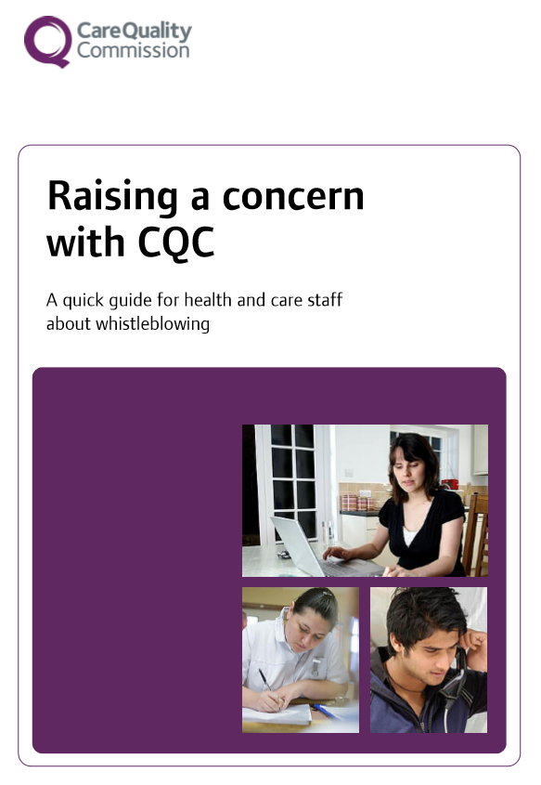

You should always try and resolve any concerns within the organisation first unless you have a clear belief that there is no one within the organisation who will take your concerns seriously or you have reason to believe you will receive adverse treatment if you do raise your concerns internally.

If you have tried to raise your concerns internally and this has either failed to resolve the issue or you have experienced unfair treatment as a consequence of raising your concerns then in these circumstances you can contact the relevant ‘prescribed body’,

If you feel your concern has not been addressed or the issues have not been resolved satisfactorily, you may wish to use the National Whistleblowing Helpline to support you to pursue the matter.

If there is nothing more you can do inside the organisation, then you can raise a concern with the regulator. In our case this is the Care Quality Commission (CQC).

They have a confidential number you can call on 03000 616161.

CQC produce a document entitled ‘Raising a concern with CQC: a quick guide for health and care staff about whistleblowing.
This can be downloaded from their website.

If you do decide to contact an external agency, you need to have reason to believe that the information you give and any allegation you make is substantially true. If you only suspect something, then that is not enough when you report concerns outside of where you work.

Talking to the police, the media and MPs, are also protected under the PIDA law, but only under certain circumstances. For example, if you genuinely believe you would be victimised or bullied if you raised the matter internally or with a regulator, you would probably be protected.

Doing this could have an impact on your employment and it is a good idea to get advice before telling anyone outside of work.

Going to the media should always be the last resort. You should not do this unless you have exhausted all other avenues.

Questions ….
Now you have read this workbook, please answer the following questions

1: What is meant be whistleblowing’?
Whistleblowing is the term used when someone who works for an employer raises a concern about malpractice, risk (for example about service user safety), wrongdoing or possible illegality, which harms, or creates a risk of harm, to people who use the service, colleagues or the wider public.

2: What is whistleblowing also known as?
Making a disclosure in the public interest.

3: What is the law called that relates to whistleblowing?
The Public Interest Disclosure Act

4: What does this law seek to ensure?
This provides legal protection against reprisals for workers who raise concerns in the public interest (also known as making a disclosure) about a danger, risk, malpractice or wrongdoing in the workplace which affects others.

5: What do you need to do to ensure that you are protected under this law?
The disclosure must be in the public interest, the worker must have a reasonable belief that the information shows that one of the categories of wrongdoing listed in the legislation has occurred or is likely to occur, and the concern must be raised in the correct way.

The worker must also make the qualifying disclosure to one of a number of ‘specified persons’ set out in PIDA, which include:
a) The worker's employer or,
b) the relevant ‘prescribed body’.

6: What concerns are you entitled to whistle blow about?
a) That a criminal offence has been committed, is being committed, or is likely to be committed

b) That a person has failed, is failing, or is likely to fail to comply with any legal obligation to which he is subject

c) That a miscarriage of justice has occurred, is occurring, or is likely to occur

d) That the health and safety of any individual has been, is being, or is likely to be endangered

e) That the environment has been, is being, or is likely to be damaged

f) That information tending to show any concerns relating to the above have been, or are likely to be deliberately concealed.

7: What are these type of concerns collectively known as?
Qualifying disclosures.

8: What is a ‘prescribed body’?
A ‘prescribed body’ is an organisation that has regulatory authority and / or legal powers for a particular sector or area of responsibility and which is identified under the PIDA as able to receive concerns about organisations.

9: Who is the ‘’prescribed body’ for our sector?
The Care Quality Commission (CQC)

The National Whistleblowing Helpline
Or
Public Concerns at Work.

10: Why is it important to follow our whistleblowing procedure correctly?
To ensure that you remain protected under the law.

11: To follow our whistleblowing procedure what might you first look to do?
Raise your concerns informally with either the individual(s) concerned or with a manager within the company.

12: If this is unsuccessful what should you do next?
Read the Whistleblowing Policy and Guidance Notes and follow the Whistleblowing Procedure.

13: Which organisations can you contact to get free, confidential and independent advice?

14: When should you raise your concerns and why should you do this?
Immediately or at the earliest
opportunity as this could stop the issue from becoming more serious, dangerous or damaging.

15: Are you permitted to find out if other workers share your concerns so that they might be raised as a group?
Yes.

16: If you are raising your concerns formally, who should you first raise them with?
Your line manager or a more senior manager within the company.

17: What should you make clear if you are raising a formal concern?
That you are raising it in line with our Whistleblowing Policy and the Public Interest Disclosure Act 1998 (PIDA).

18: When raising a concern what should you focus on?
That you include as much evidence / factual information as possible.

This means things like being specific about:

- dates and times
- what happened and the order of events
- who was involved
- any witnesses.

19: What should you also do if you raise a concern?
Keep a written record of what is happening.

20: What is your understanding around raising concerns anonymously?
This is not the preferred option.

Whist every effort will be taken to protect a person’s anonymity, it may not always be possible.

People maybe able to work out who raised the concern and there
may be circumstances where a person has to be identified.

It also makes it difficult for the
organisation / prescribed body to
identify the individual and contact them to get further information.

It also means the organisation /
prescribed body will not be able to feedback what they have found and any actions they have taken.

21: What can you expect and what might you not be able to be provided with in relation to feedback once the concerns you have raised have been investigated?
Your can expect feedback but the organisation / prescribed body may not be able to tell you about the precise actions they have taken where this would infringe a duty of confidence that they owe to another person.

22: What can you do if you are not satisfied?
If you feel your concern has not been addressed or the issues have not been resolved satisfactorily, you may wish to use the National Whistleblowing Helpline to support you to pursue the matter.

If there is nothing more you can do inside the organisation, then you can raise a concern with the Care Quality Commission.

23: What must you be clear about before you contact an external agency?
That the information you give and any allegation you make is substantially true. If you only suspect something, then that is not enough when you report concerns outside of where you work.

24: Under what circumstances are you able to talk to the police, media or your MP and remain protected under the law?
If you genuinely believe you would be victimised or bullied if you raised the matter internally or with a regulator.

