POLICIES AND PROCEDURES

INTERACTIVE GROUP SESSION

Top 3 problems with policies and procedures
- Employee sign off
- Understanding content
- Review and updating

- Employee understanding and embedding information
- Evidencing staff have seen them
- Jargon and language
- Policy details must be brief/concise and relevant
- Accessing -especially in home care where face to face time is limited
- Constant time/review
- Is content exact to policy?

- Time constraints-receiving and monitoring
- How can we be sure staff have understood what they have read?
- Wordy/legalistic policies -easy read needed.

- Staff reading and understanding
- Seniors/managers not using policies to address issues
- Updating

- Make time to read
- Don’t know all policies but know where to look
- Keeping up to date with best practices and legislation
- Cost/no cost way

- Staff awareness/recognition of importance
- Volume
- Reviewing/ensuring it is still relevant
- Staff’s understanding/formal language

- Read/understanding
- Review/updates
- Expectation of performance

- Getting staff to read them
- Reviewing
- Poorly structured
- Policy/Procedure/Guidance

- Employees reading them
- Staff understanding content
- Relevance of some
- Volume of policies make it difficult for people to identify important ones
- Length of some policies
- Not always strict “rules”, you have to formulate your own opinions for certain topics
- Getting staff to read and sign them. To show their understanding as evidence
- Having time to read the policies and procedures
- Putting into practice -easy read – accessibility
- Keeping up to date with the reviewing (when legislation changes)

- Staff read/understand them
- Make sure they don’t contradict each other
- Making sure they are updated

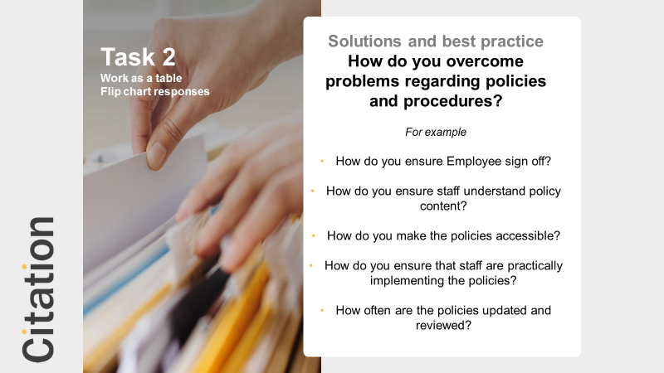

Overcoming problems with policies and procedures
- Time frame for review of policies
- Easy read on computer management system
- Cover updates only at staff meetings
- Inclusion in training
- Quizzes/questions to check understanding
- Inclusion in Supervision (few at a time)
- Observation -putting into practice
- Challenging faulty application

- Policy of the month
- Action Learning for management
- Supervision
- Accessible on line

- Give staff allotted time. Make them easy read.
- Reduce size of policy -Don’t contradict!
- Association membership -sample policies/cut costs/info around best practice
- Themed Supervision -certain policies/training sessions

- Summary Booklets
- Relating to policies on supervisions and providing copies
- Providing observations -auditing
- Being present and advising
- Reviewing policies and procedures annually or when needed

- On-line -check sign offs
- Extended time for reviews
- Intranet -forum
- Supervision -reports
- Inductions -specific to role

- Read a few at a time. Do an audit to check staff have read them. To see if they have understood all the content (Q&A)
- Checking at 1:1 meetings
- Update the staff team on any changes, any new policies that have been put in place
- Look for evidence that it has been used in practice
- Asking the managers and spot checking
- Add a question and answer section (FAQs)

- Policy every month made available to all staff to read and date. Evidence that they have read it. Meetings/Supervisions
- Checking home’s policies/procedures to ensure they don’t cross over especially when updating
- Electronic devices -will flag up when need updating (i.e. Care docs)

- Time to sign off
- Policy and Procedure to be simpler, easy to read
- Supervising/Monitoring

- New policies discussed in meetings
- Main policies signed off in supervision (Receipt email)
- Brief in meetings (short and concise)
- Accessible (Policy file in office) Email (Home Care)
- Reviewed every year (different months)

- Knowledge check sheets on major policies/Quick easy Q&A sheets
- Circulation sheet in Communication file
- Bulletin
- Talk about in Supervision
- Employee Handbook
- Discussion
- Training for staff each month in “policy of the month”

- Include in training as part of it not key to it
- Condense down by department, what they need to cover
- Lots of copies around the company
- Pick a policy to discuss knowledge at supervisions -themed discussions or at staff meetings
- Put them in wage slips -don’t read them though!
- Updated at time needed and annual review
- Encourage Diploma/NVQ which means staff need to know them
- Encourage people to have an overview -make it clear don’t have to know all details but look up as needed

RESPONSES FROM 11 TABLES

