Information provided to assess capacity and obtain informed consent

Managing your medication

Helping you with your prescribed medication

If you have been prescribed medication by your doctor, then one of our responsibilities as your support provider is to ensure that you take your medication in the way that your doctor wants you too. We will talk to you about whether you need help with this.

Areas where we can help

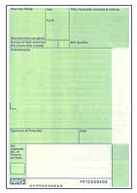

If you do need to take medication to help you stay well, we can provide you with support around:

- Attending doctor’s appointments
- Ordering and picking up your medication from the pharmacy (chemist). This can include arranging for repeat prescriptions
- Checking the medication that arrives for you is correct and is stored safely
- Taking your medication. We will keep a record of each medication that you take and the day and time that you take it.
- Returning any medication which you no longer need to the pharmacy so that it is disposed of correctly.
- Taking non prescribed medication such as Paracetamol or Homely Remedies
- Meeting with your doctor to review your medication.

Supporting you to manage and take your own medication

If you are able to (and want to) manage your medication yourself then we can support you to do this. This is called self medication. If this would be hard for you or you do not want the responsibility then we can provide you with full support to manage your medication or support in particular areas.

Keeping full medication records

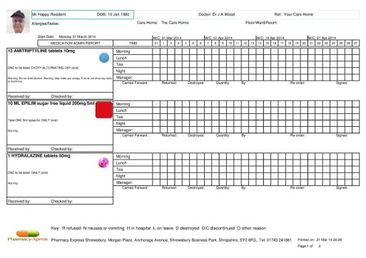

Whenever staff are involved in supporting you to manage your medication we will keep full records of all medication that we hold on your behalf. When staff administer your medication, we will keep records of the medication you received, when you received it and who administered it to you.

Obtaining your consent

If you need staff support with your medication, then we need to ask your permission to provide this. This is called providing your consent. We will ask you to sign a consent form agreeing to our staff supporting you with your medication. This will be kept in your personal file and you can review it at any time.

