Survey for service users and their representatives

Please tell us about your experience …

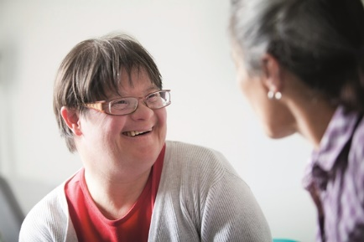

Are you involved in discussions and making decisions that affect you?
 |  | Yes |  | Not always |  | Don’t know
Do staff involve you in discussions and making decisions about the care and support you receive and any other issues that affect you?
Are you involved in discussions about risks that affect you and how you can be supported to do things safely?
Are you asked about what you want and the things that are important to you?
Do staff help you to make day to day decisions like what you want to wear, what you want to eat and drink and what you want to do?
Are you able to choose how you decorate your bedroom?
Are you involved in discussions and decision making about any health needs you may have?
Any comments or suggestions:
Are you provided with information that you are able to understand?

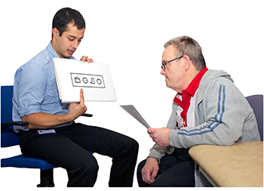

 |  | Yes |  | No |  | Not always
Are you provided with information in a way that helps you to understand it?
Do staff take time to go through information with you and explain it to you if you need them to?
Any comments or suggestions:

Are you provided with information that you are able to understand? cont’d …

Have you been provided with information about: |  | Yes |  | No |  | Don’t know
Keeping safe
The support the service can provide
Planning your care and support
Healthy lifestyles and healthy eating
What you should expect from the service and staff
How to help us to prevent the spread of infection
Visiting arrangements
How to raise concerns or make a complaint
Any comments or suggestions:
Have you agreed to the care and support you receive and provided us with your permission (or consent)?

Does the service and staff seek your consent (permission) to: |  | Yes |  | Not always |  | Don’t know
provide you with support with your personal care
provide you with support with your medication
provide you with support with your money and finances
share personal information about you with your family members or professionals from other organsiations if they need to
take and use any photos of you
Before providing you with care and support in these areas, do staff check with you that you are still happy for them to do so?
Any comments or suggestions:

Eating and drinking and your mealtime experience

 |  | Yes |  | No |  | Not always
Do staff know the things you like to eat and drink?
Are staff aware of any special dietary requirements you may have?
Are you involved in choosing what you drink and the food you eat?
Is the food that is provided appetising and tasty?
Do you enjoy mealtimes and can choose when and where you eat?
Are you able to choose an alternative if you do not want the food that is on offer?
Do you receive the support around eating and drinking if you need some extra help?
Any comments or suggestions:

Are you encouraged to stay healthy?

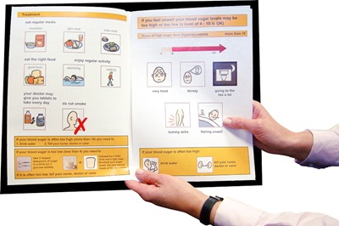

 |  | Yes |  | Not always |  | Don’t know
Are you encouraged to eat and drink healthily and are there healthy options available for you?
Are you encouraged to have an annual health check each year with your doctor?
Do you have a Health Action Plan which helps you to think about how to look after yourself and how to keep healthy?
If you are unwell, do staff make sure that you get the help you need from the right healthcare professionals?
Any comments or suggestions:
What do you think of the staff who support you?

 |  | Yes |  | Not always |  | Don’t know
Are you always treated kindly and talked to nicely by staff?
Do you find the staff approachable and easy to talk to?
Do you feel that staff respect you and try their best to make sure your needs are properly met?
Do staff take time to listen to you and help you if you are worried or upset?
Do you feel staff understand you and what is important to you?
Do staff help you to make your own choices and decisions and to decide what to do?
Do staff encourage you to do as much as you can for yourself so that you are as independent as possible?
Do you feel staff respect your personal privacy? Do they also keep your private information safely locked away and not say private things about you in front of anyone who does not need to know that information?

What do you think of the staff who support you? cont’d …

 |  | Yes |  | Not always |  | Don’t know
Are your visitors made to feel welcome and can they visit pretty much whenever they want?
Do you ever feel lonely?
Any comments or suggestions:

Are you involved in reviewing your care and support?

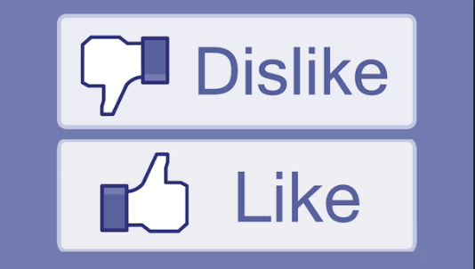

Every so often are you involved in reviewing: |  | Yes |  | No |  | Not sure
Your Care and Support Plan and the care and support you receive from the service
The risks that affect you and how these are managed
Whether you are still happy to consent to the things that you have agreed to?
The activities you want to do
The things you want to eat and drink
Any comments or suggestions:

Raising concerns and making complaints

 |  | Yes |  | No |  | Not sure
If you are unhappy do you know how to raise a concern or make a complaint?
Would you feel confident to raise a concern or make a complaint if you needed to?
If you did want to raise a concern or make a complaint, would you need extra support from someone in order to do this?
If you did raise a concern or make a complaint do you feel confident that this would be dealt with fairly, properly and promptly?
Any comments or suggestions:

Service improvement

 |  | Yes |  | No |  | Not sure
Are you happy with the service you receive from us?
Are there any ways that you think we could make the service better for you?
Any comments or suggestions:

