Equality, Diversity
and
Human Rights

A training workbook for staff

Introduction

As a company we believe that all human beings have equal worth and should be afforded equal respect regardless of their gender identification or sexuality, their race, their religion or belief system, their cultural identity, their age, their marital status or their disability.
As a consequence of this we have developed polices around:

1. Ensuring equality, respecting diversity and preventing discrimination
2. Upholding people’s human rights.
This workbook is designed to promote your understanding of and to encourage you to practice in line with these two key policies.

Our policy statement in relation to respecting diversity

As a company we believe that diversity or ‘the differences between people’ are a source of richness and something that should be valued. It would be a dull world indeed if we were all the same.

The differences between people brings with it different experiences and perspectives. Welcoming diversity can therefore result in greater tolerance and enhance our collective learning and understanding.

We believe that individuals and societies are richer when there is a mutual appreciation of the differences between people and it is our objective to promote this within our workplaces, amongst both staff and people who use our services.

Hurray for diversity!

Our policy statement in relation to ensuring equality

As a company we believe that if all human beings have equal worth then they should be afforded equality of opportunity. We believe that no one should be subject to discrimination or marginalisation on account of any ‘protected characteristic’, Indeed to do so would be unlawful.

In endeavouring to ensure equality of opportunity, we adopt an ‘equalities approach’.

Whilst normally we would provide the same information or resources to everybody, an equalities approach recognises that in certain circumstances we may have to do things a little differently for some people in order to provide them with the same opportunity as other people.

This concept is neatly illustrated in the illustration below but it is also the basis of making ‘reasonable adjustments’ for people with disabilities.
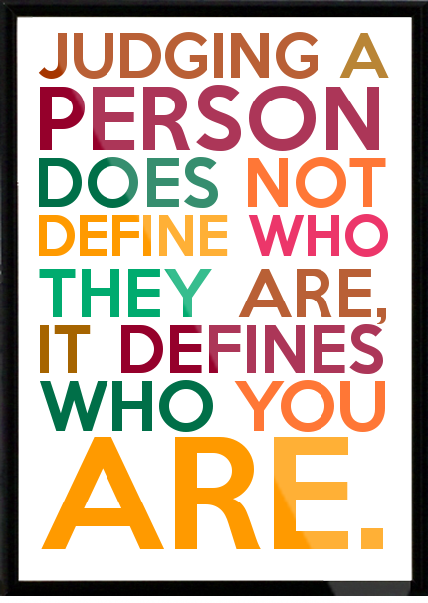
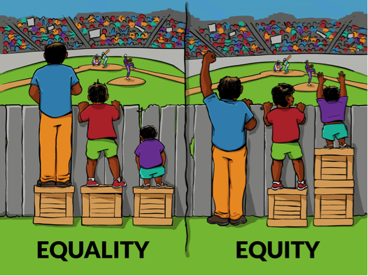

What is meant by discrimination?
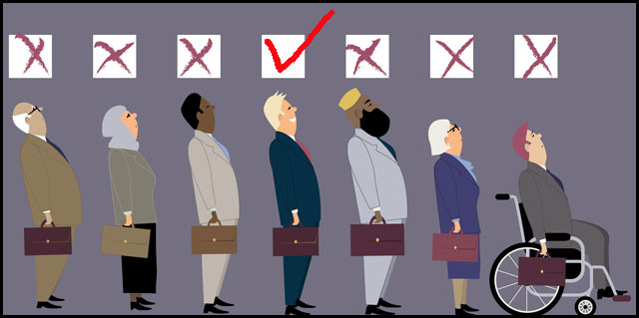
Discrimination is the less favourable or bad treatment of someone because of one or more aspects of their social identity.

What is meant by prejudice?

Prejudice is the existence of attitudes, feelings and opinions held towards groups of people (because of characteristics such as their gender, sexuality race or religion) which they have formed without true knowledge, thought, or reason.

Everybody judges others by their own codes and from their own memories and therefore to varying degree we all hold prejudices. It is important therefore that we know what these are so that they don’t adversely influence the way we support people.

What is meant by stereotyping?

Stereotyping involves generalisations about the "typical" characteristics of members of particular groups.

An example might be ….
John is male, so he likes football, going to the pub and he doesn’t do the washing up ...
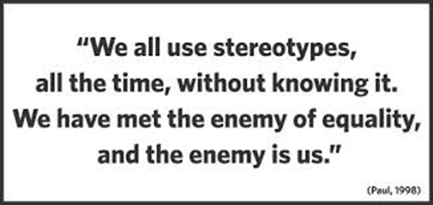
Our policy statement in relation to preventing discrimination

It is our policy to ensure that neither our staff nor the people we support experience discrimination, marginalisation or exclusion because of age, disability, gender reassignment, marriage and civil partnership, pregnancy and maternity, race, ethnic origin, colour, nationality, national origin, religion or belief, sex and sexual orientation.
As a Company we wish to ensure a culture which does not tolerate prejudice or discrimination. We are supporting a group of people who have historically been marginalised. Our job is to not only meet their individual needs but help them to be accepted by society and their community.

What to do if you feel that you or someone we support is being discriminated against

If as a member of staff you believe you are being subject to discrimination or you feel that a person we support is being discriminated against, you have a number of options.

It is within your rights to challenge that discrimination directly with the person who is discriminating.

If you do not feel able to do this or you have tried and found that your concerns have not been resolved then we would encourage you to raise your concerns with your line manager or a senior manager within the company.

Your concerns will then be investigated thoroughly and if discrimination is found to have taken place, this will be dealt with under our Disciplinary Policy & Procedure.

The Equalities Act 2010
Historically the law in the UK relating to equalities (equalities legislation) developed at different times for different groups of people. For example there was:

- The Equal Pay Act 1970
- The Sex Discrimination Act 1975
- The Race Relations Act 1976
- The Disability Discrimination Act 1995
- The Equality Act (Sexual Orientation) regulations 2007.

The Equalities Act was introduced to bring all previous laws relating to promoting equality into a single piece of legislation. It has replaced these previous pieces of legislation and provides the current framework for all equalities law.

A lot of what was in the previous legislation has been retained although elements have been extended to include other groups and updated to provide a consistent legal framework.

Protected characteristics
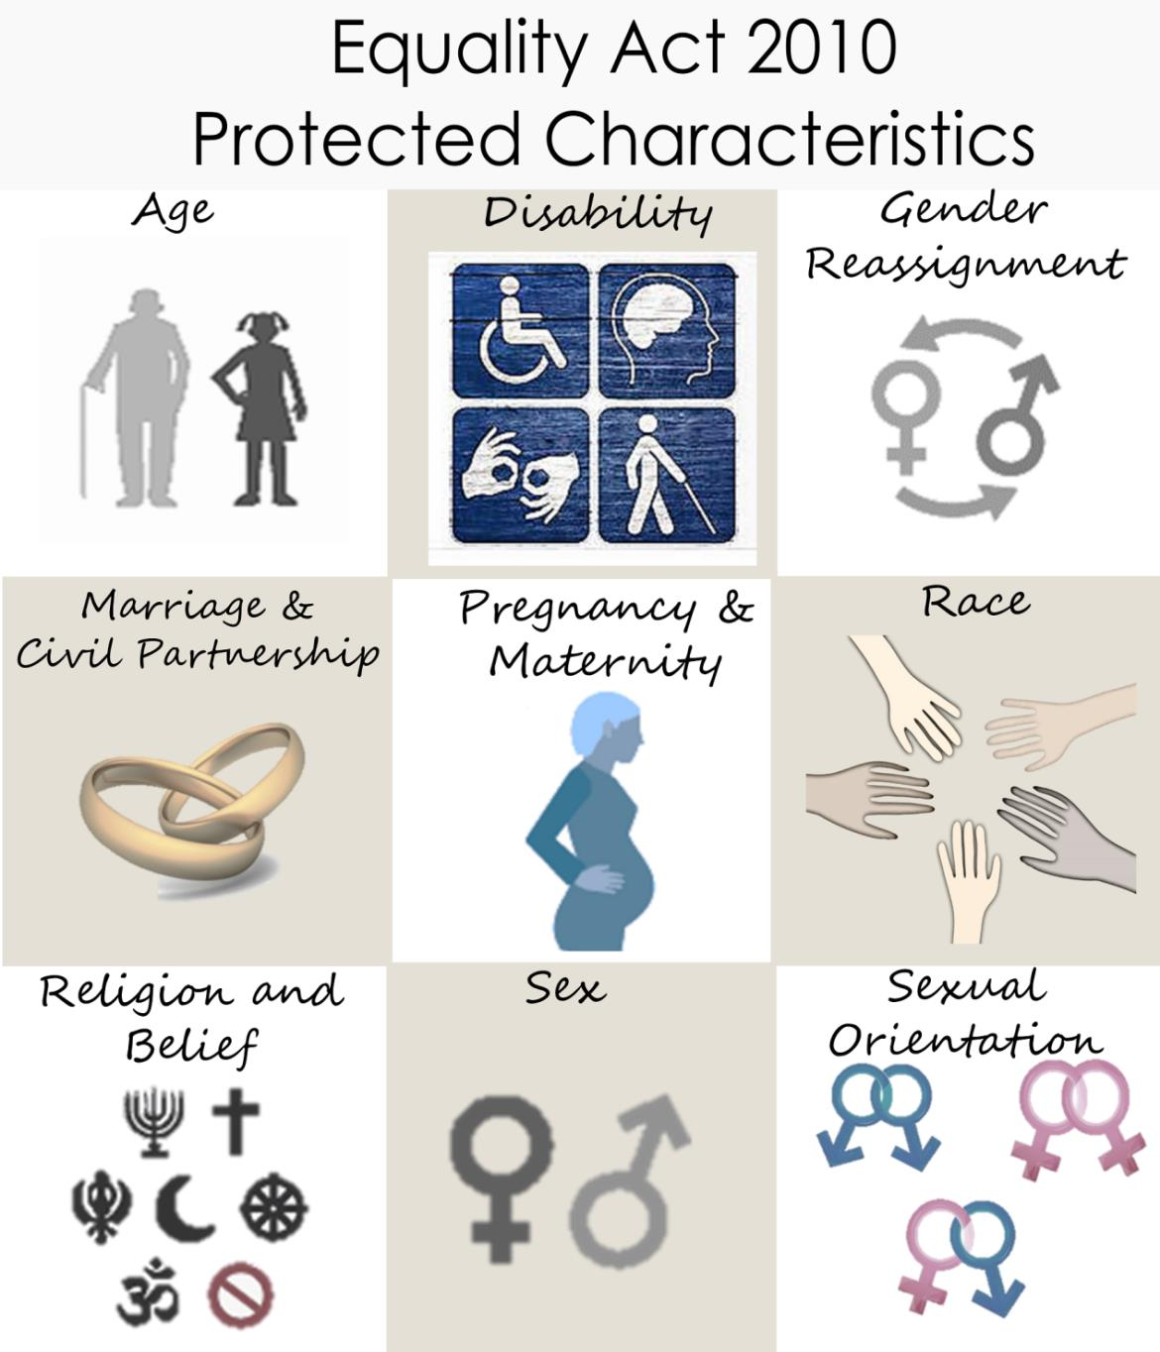
The Equalities Act 2010 identifies a number of ‘characteristics’ that are ‘protected’ from discrimination and unfair treatment under equalities law. These are:
- Age
- Disability
- Gender reassignment
- Marriage and civil partnership
- Pregnancy and maternity
- Race
- Religion and belief
- Sex
- Sexual orientation.

The Equalities Act 2010 and unlawful discrimination
The Equality Act 2010 defines the different types of discrimination that are unlawful. These are:

Direct discrimination
Direct Discrimination is when someone is treated less favourably than another person because of a protected characteristic.

Examples of direct discrimination would be refusing to recruit a woman because she is pregnant; or excluding one staff member from a team training event on account of their disability or race.

Indirect discrimination
Indirect discrimination is when you have a condition, rule, criteria, policy or practice that applies to everyone but particularly disadvantages people who share a protected characteristic.

An example of indirect discrimination would be a manager continually holding team meetings on a Monday, which is a day that a part-time member of the team does not work.
Associative discrimination
Associative discrimination is where an individual is directly discriminated against or harassed for association with another individual who has a protected characteristic.

An example would be not promoting a staff member because they care for a parent who had a stroke. This is discrimination against the staff member because of their association with a disabled person.

Perceptive discrimination
Perceptive discrimination is where an individual is directly discriminated against or harassed based on a perception by others that they have a particular protected characteristic. It applies even if the individual does not actually possess that protected characteristic.

An example would be if colleague A harasses colleague B because they think colleague B is HIV positive, even though they are not. Colleague A has made assumptions and discriminated against colleague B, based on a perception.

Discrimination arising from disability
Discrimination arising from disability is where an individual has been treated unfavourably because of something connected with their disability (so does not have to be the disability itself).
An example would be disciplining a staff member for repeated spelling mistakes that are in fact caused by dyslexia. This type of discrimination is unlawful where the employer (or a line manager) knows, or could be reasonably expected to know, that the person has a disability.

Harassment
Zero tolerance of harassment
Harassment is unwanted conduct related to one of the protected characteristics that has the purpose or effect of violating a person’s dignity or creating an intimidating, hostile, degrading, humiliating or offensive environment for that individual.

It does not matter whether or not this effect was intended by the person responsible for the conduct.

Employees can complain of behaviour that they find offensive even if it is not directed at them and the complainant does not need to possess any of the protected characteristics themselves.

Victimisation

Victimisation is when an employee is treated badly and subjected to detriment, such as being denied a training opportunity or a promotion because they made or supported a complaint or raised a grievance under the Equality Act 2010, or because they are suspected of doing so.

An example might be if a disabled staff member raises a grievance that the line manager is not complying with the duty to make reasonable adjustments and is then systematically excluded from all meetings.

Making ‘reasonable adjustments’
The Equality Act introduces a legal duty for employers and organisations to make ‘reasonable adjustments’ for people who have a disability.

Reasonable adjustments are positive steps that employers and organisations must legally take to remove any barriers people face to working in or accessing their service because of a disability.

The Equalities Act says there's a duty to make reasonable adjustments if someone is placed at a substantial disadvantage (more than minor or trivial) because of their disability compared to non-disabled people or people who don't share their disability.
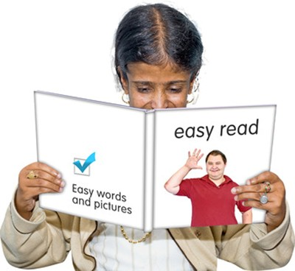

The duty to make reasonable adjustments includes:
Changing the way things are done
An example might include a GP offering someone a double appointment or a home visit because these adjustments would be required to enable a person with a disability to get an effective service from them.

Changing the physical features or layouts of buildings
If the physical features of a building or other premises make it more difficult for people with disability to access them then there may be a case for reasonable adjustments to be made.

This could include making sure there is effective access to the building through the provision of ramps or lifts. Making sure that there are toilet facilities with disabled access and making sure that places that people need to access are clearly and properly signed.

Providing extra aids and services
Some people may require particular aids or equipment to help them access or do something or they may need additional services.

Examples of these auxiliary aids and services might include providing information in in alternative formats such as Braille or audio CDs or extra staff assistance. Hospitals for example have Learning Disability liaison nurses.

Promoting people’s Human Rights
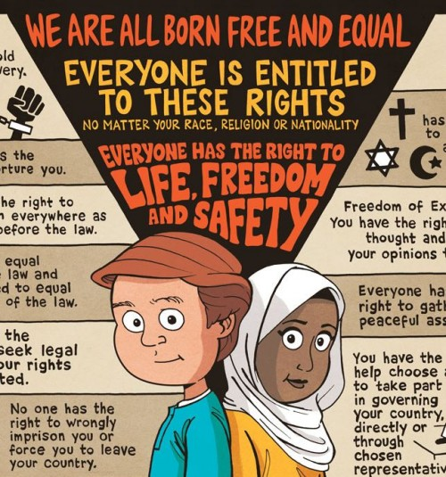
Human rights are rights that is believed belong to every human being. They are innate rights. They cannot be given to people. They can only be claimed or fulfilled.
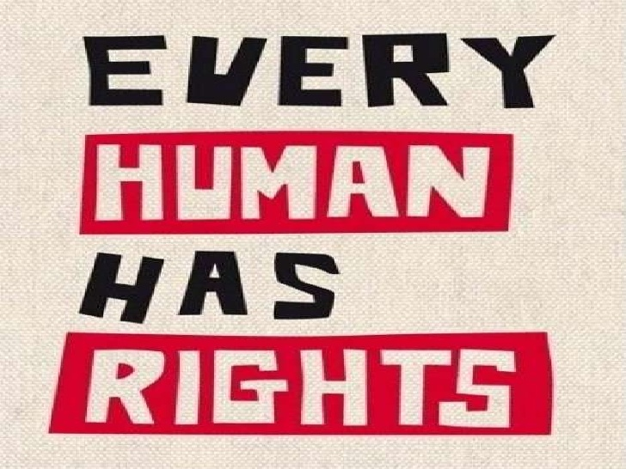

The Human Rights Act 1998

The Human Rights Act 1998 came into force in the United Kingdom in October 2000. It is composed of a series of sections that have the effect of integrating the protections in the European Convention on Human Rights into UK law.

The Act sets out the fundamental rights and freedoms that individuals in the UK should have access to.

These fundamental rights include:

- Right to life
- Freedom from torture and inhuman or degrading treatment
- Right to liberty and security
- Freedom from slavery and forced labour
- Right to a fair trial
- No punishment without law
- Respect for your private and family life, home and correspondence
- Freedom of thought, belief and religion
- Freedom of expression
- Freedom of assembly and association
- Right to marry and start a family
- Protection from discrimination in respect of these rights and freedoms
- Right to peaceful enjoyment of your property
- Right to education
- Right to participate in free elections.

All public bodies (such as courts, police, local governments, hospitals, publicly funded schools) and other bodies carrying out public functions have to comply with the Convention rights. This includes Innovations Wiltshire.
Promoting people’s human rights is part of what we do

The UN Convention on the rights of people with disabilities
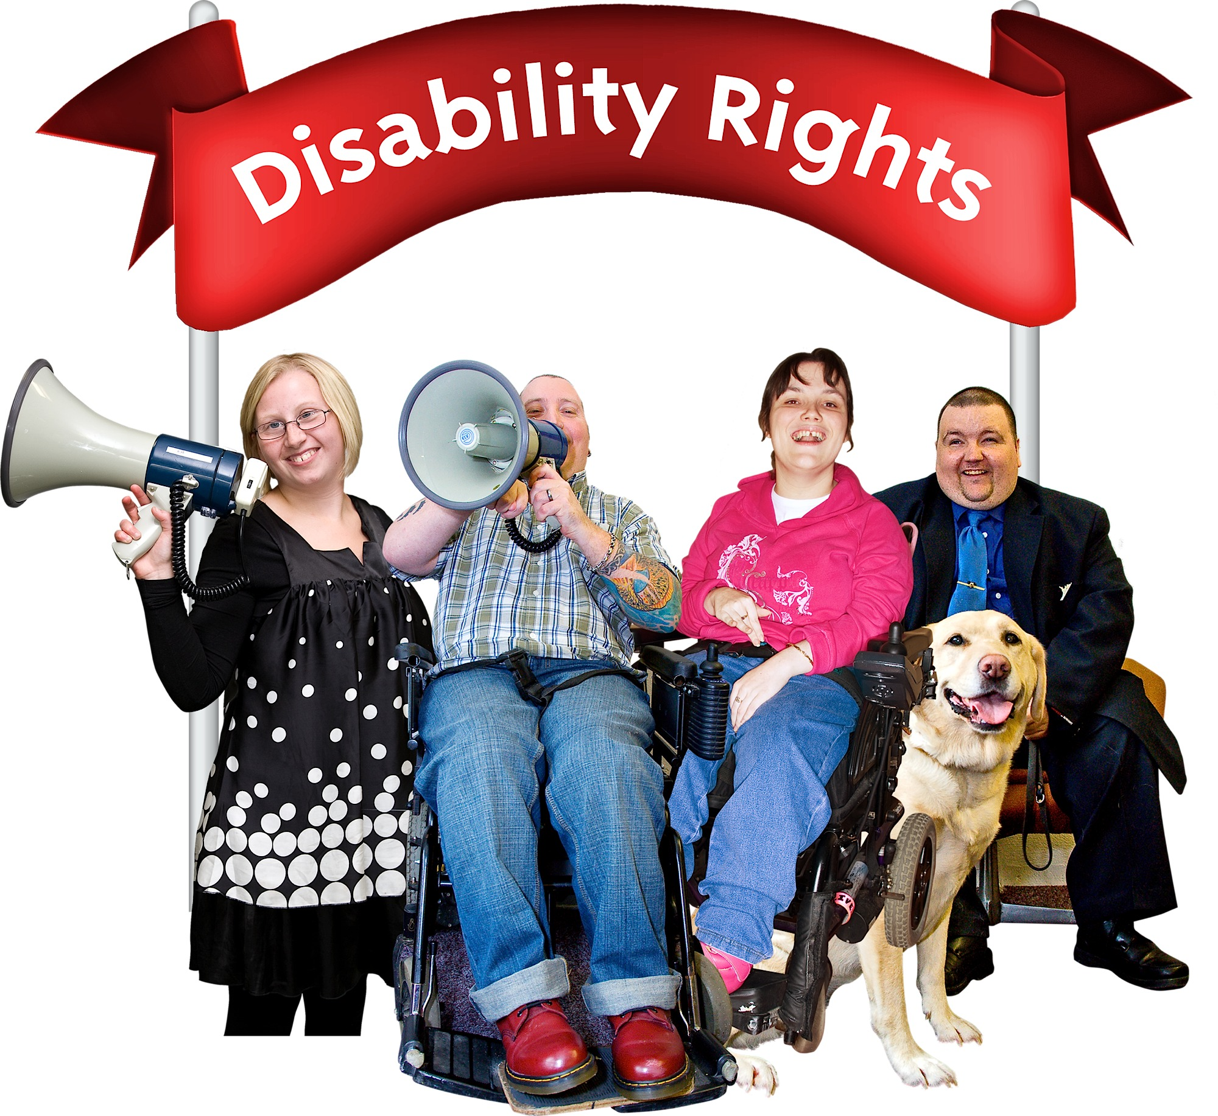
The UN Convention on the rights of people with disabilities specifically identifies the rights of people with this protected characteristic to be:

- Equality and non-discrimination
- Accessibility
- Life
- Freedom from torture or cruel, inhuman or degrading treatment, exploitation, violence or abuse
- Live independently and being included in the community
- Personal mobility
- Freedom of expression and opinion, and access to information
- Respect for privacy, for home and the family
- Equal access to health services and rehabilitation.

Core Human Rights principles

The principles of Fairness, Respect, Equality, Dignity, and Autonomy are commonly agreed ‘human rights principles’. They are considered to underpin all international human rights treaties. These are sometimes called the FREDA principles.

The ‘right to life’ and ‘staff rights and empowerment’ have also been added to these for the purposes of our work.

The principles we use to promote and uphold people’s human rights are therefore:

Fairness
It is fair that people who use services and people acting on their behalf have access to clear and fair processes for getting their views heard, for decision-making about care, support and treatment and to enable them to raise and resolve concerns or complaints.

Respect
People who use services should be valued as individuals and are listened to.

What is important to them should be viewed as important by the service. People acting on behalf of others, such as family and friends should also be valued and listened to.

Equality
Any person who uses services should not experience discrimination and should have their needs met. This includes any needs they have associated with their age, disability, gender, race, religion and belief, sexual orientation, gender reassignment and pregnancy and maternity status.

This includes looking at the needs of people who may experience multiple discrimination or disadvantage as a consequence of having more than one of the above protective characteristics.
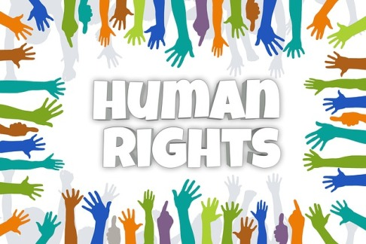
Dignity
People who use services should always be treated in a humanitarian way. This means with compassion and in a way that values them as a human being and supports their self-respect, even if their wishes are not known at the time.
Autonomy
People who use services should be able to exercise the maximum amount of choice and control possible whether this be in care planning, in their individual care, support and treatment, in service development, in their relationships with others such as family and friends and as citizens beyond the health and social care services that they are using.

Right to life
People who use services must have their right to life protected and respected by the health and social care services that they use.

Staff rights and empowerment
Staff working in health and social care should also have their human rights protected and respected. This includes being encouraged to freely speak up about concerns and have these considered, being free from unlawful workplace discrimination, harassment, bullying or violence and being supported and empowered to promote the human rights of people using their service.
CQC and Human Rights
CQC are making the promotion and upholding of people’s human rights central to their regulation and inspection process. The reasons for this are that:

1. Care and support services are often provided to the most vulnerable members of our society who are potentially at risk of not having their human rights respected and in addition not being in a position to challenge this if it was to occur.

2. Inquires such as the Francis report into Mid Staffordshire Hospital have found that the human rights of patients were not being upheld and the NHS was not applying ‘core humanitarian values’.

CQC are not inspecting for compliance with the Human Rights Act. Instead they are inspecting to see how providers are incorporating these Human Right principles into their five Key Lines of Enquiry. These five Key Lines of Enquiry are:

- Is the service Safe?
- Is the service Effective?
- Is the service Caring?
- Is the service Responsive?
- Is the service Well led?

A full breakdown of how we might align these CQC’s Key Lines of Enquiry framework can be found in our ‘Upholding Human Rights; Policy and Guidance Notes’.

Is the service safe?
Human rights principle |  | What we need to ensure (and CQC will be looking at)
Fairness |  | The people we support and / or their chosen representatives are involved in assessing risks that affect them and their own safeguarding if they choose to be and have the mental capacity to do so.
 |  | The Deprivation of Liberty safeguards are applied when necessary and used correctly.
 |  | The people we support and / or their chosen representatives are made aware of how to raise concerns or make complaints and that they are encouraged to if they feel they need to.
Respect |  | Where risk assessments take place in relation to levels of harm, people we support and their chosen representatives are consulted and their experiences included.
Equality |  | That discriminatory abuse is clearly discouraged and if it is found to have taken place it is dealt with and addressed directly.
Dignity |  | Taking all steps to ensure that abuse that impacts on dignity (e.g. neglect) does not take place and if it is found to have taken place that it is raised as a Safeguarding concern and dealt with through the safeguarding process.
 |  | That the environment is habitable. It is warm, comfortable and safe as well as clean and hygienic.
Autonomy |  | The people we support and / or their chosen representatives are made aware of what abuse is, what to do if they encounter it and can be involved in the safeguarding process if they choose to be.

Is the service safe?
Human rights principle |  | What we need to ensure (and CQC will be looking at)
Autonomy |  | Restrictive practices, including restraint, are minimised through the use of person-centred approaches.
Right to life |  | People are protected from avoidable death through the safe management of the environment and equipment and through referral to appropriate healthcare services as and when they need to be.

Is the service caring?
Human rights principle |  | What we need to ensure (and CQC will be looking at)
Fairness |  | Staff ensure that people have access to advocacy as and when they need it.
 |  | Staff ensure that people’s personal information remain confidential and is held securely.
 |  | There is a clear procedure by which the service can exercise its ‘duty of candour’ and honesty share bad news with relevant parties if something goes wrong.
 |  | Staff gather and use the views of people using the service and their chosen representatives in order to make improvements to the service.
Respect |  | Staff include the people we support and (with their permission) their chosen representatives as partners in the provision of the service.
 |  | Staff build relationships of trust through openness and honesty in communication with people using the service and their chosen representatives.
Equality |  | Staff avoid discrimination.
 |  | Staff and the service are willing and able respond to respond to the diversity of people’s needs whatever they are. This might include their cultural needs including the community they wish to be in contact with, the relationships they wish to maintain and their communication needs.
Dignity |  | Staff provide consistently compassionate care.
 |  | When required, staff meet people’s needs in relation to pain relief.

Is the service caring?
Human rights principle |  | What we need to ensure (and CQC will be looking at)
Dignity |  | Staff meet people’s needs in relation to eating and drinking.
 |  | Staff meet people’s needs in relation to going to the toilet.
 |  | Staff meet people’s needs in relation to privacy.
Autonomy |  | Staff work with people to maximise their independence.
 |  | Staff support people who use services to maintain the friendships and relationships that are important to them.
 |  | Staff minimise the use of restrictive practices.
 |  | Staff use good practice in restraint.
Right to life |  | That the people we support are never subject to neglect by staff both in relation to their day to day needs and longer term needs which may require them to have timely and effective access to healthcare services.

Questions ….
Now you have read this workbook, please answer the following questions

1: What are our views as an organisation about the value of diversity?
The differences between people are a source of richness.

The differences between people brings with it different experiences and perspectives.

Welcoming diversity can therefore result in greater tolerance and enhance our collective learning and understanding.

We believe that individuals and societies are richer when there is a mutual appreciation of the differences between people

2: What is our policy statement in relation to ensuring equality?
As a company we believe that if all human beings have equal worth then they should be afforded equality of opportunity. We believe that no one should be subject to discrimination or marginalisation on account of any ‘protected characteristic’.

3: What is recognised in an ‘equalities approach’?
An equalities approach recognises that in certain circumstances we may have to do things a little differently for some people in order to provide them with the same opportunity as other people.

4: What is meant by discrimination?
Discrimination is the less favourable or bad treatment of someone because of one or more aspects of their social identity.

5: What is meant by prejudice?
Prejudice is the existence of attitudes, feelings and opinions held towards groups of people (because of characteristics such as their gender, sexuality race or religion) which they have formed without true knowledge, thought, or reason.

6: What is stereotyping?
Stereotyping involves generalisations about the "typical" characteristics of members of particular groups.

7: Why was the Equalities Act 2010 introduced?
To bring previous equality related legislation that had been developed at different times for different groups of people into a single piece of legislation.

8: What is meant by ‘protected characteristics?
Protected characteristics are the characteristics identified in the Equalities Act 2010 that are protected from discrimination and unfair treatment under equalities law.

9: List the nine protected characteristics
- Age
- Disability
- Gender reassignment
- Marriage and civil partnership
- Pregnancy and maternity
- Race
- Religion and belief
- Sex
- Sexual orientation.
10: What is our policy statement in relation to preventing discrimination?
It is our policy to ensure that neither our staff nor the people we support experience discrimination, marginalisation or exclusion because of age, disability, gender reassignment, marriage and civil partnership, pregnancy and maternity, race, ethnic origin, colour, nationality, national origin, religion or belief, sex and sexual orientation.

11: What is meant be direct discrimination?
Direct Discrimination is when someone is treated less favourably than another person because of a protected characteristic.

12: Give an example of direct discrimination that is different to the one provided ...

13: What is meant by indirect discrimination?
Indirect discrimination is when you have a condition, rule, criteria, policy or practice that applies to everyone but particularly disadvantages people who share a protected characteristic.

14: Give an example of indirect discrimination that is different to the one provided ...

15: What is meant by harassment?
Harassment is unwanted conduct related to one of the protected characteristics that has the purpose or effect of violating a person’s dignity or creating an intimidating, hostile, degrading, humiliating or offensive environment for that individual.

16: Does it matter whether or not the effect of the harassment was intended?
No … the issue is how it is perceived by the person it is directed at or is exposed to it

17: What is meant by victimisation?
Victimisation is when a person is subjected to poor or detrimental treatment …. Sometimes this can result in them being denied opportunities.

18: Give an example of victimisation that is different to the one provided ...

19: What is meant by ‘reasonable adjustments’?
Reasonable adjustments are positive steps that employers and organisations must legally take to remove any barriers people face to working in or accessing their service because of a disability.

There's a duty to make reasonable adjustments if someone is placed at a substantial disadvantage compared to people who don't share their disability.
20: Given some examples of reasonable adjustments ...

21: What are the 15 fundamental human rights identified in the Human Rights Act 1998?
- Right to life
- Freedom from torture and inhuman or degrading treatment
- Right to liberty and security
- Freedom from slavery and forced labour
- Right to a fair trial
- No punishment without law
- Respect for your private and family life, home and correspondence
- Freedom of thought, belief and religion
- Freedom of expression
- Freedom of assembly and association
- Right to marry and start a family
- Protection from discrimination in respect of these rights and freedoms
- Right to peaceful enjoyment of your property.
- Right to education
- Right to participate in free elections.

22: In terms of the core Human Rights principles, what does the acronym FREDA stand for?
Freedom
Respect
Equality
Diversity
Autonomy

23: What additional rights are CQC also looking at during their inspection of services?
Right to life
Staff rights and empowerment

24: In terms of upholding people’s human rights what are CQC looking at when they inspect your services ?
How providers are incorporating these Human Right principles into their five Key Lines of Enquiry.

