

Creating training presentations and accompanying resources

**Introduction**

This resource accompanies a training presentation designed to help you create your own bespoke training resources to meet your needs.

It is designed to enable you to create training resources that are fully aligned to your policies and procedures. That are available for you to use as and when you need to … with big groups, small groups and with individuals.

Part of this approach is that training sessions can be supported by resources (such as this one) that people can take away and / or access within the service when they need to. In this way you can provide them with an ongoing reference and maximise the chance of them understanding and retaining the information.

**Creating your policies and procedures**



When writing policies our advice is that they are short and to the point. A policy should clearly outline **why** you do what you do. That’s it.

Procedures are more detailed and should provide a step by step guide to **how** you do what you do.

If it is not policy or procedure but still relevant then include it as accompanying guidance notes.

**Creating training presentations**

Once you have your policy, procedure and guidance notes and you are happy that they are an accurate reflection of your views and processes and contain all the relevant information then you can develop a bespoke training presentation around this,

A drawing of a cartoon character

Description generated with high confidence

We would encourage you to think creatively around how best to do this. How might you best engage them. Remember that presentations are a very powerful way of conveying information and generating discussions but if you put too much information on your slides or don’t make the presentation thought provoking and interesting then your audience may well switch off.

Think about whether what you want to say really needs to be up there on the screen … instead could you include it as notes and use a few well chosen words in your presentation as a prompt to talk about it,

It maybe that in your accompanying resource that people can use as an ongoing reference, you put fuller text and more detailed explanations than you include in the PowerPoint presentation.

**Break down your presentation slide by slide**

You know overall what you are trying to say … now you need to work out the job of each slide. Are you introducing a topic? Are you asking particular questions? (not too many per slide) or are you unveiling information? (again not too much per slide).

**Use images**

They say a picture paints a 1000 words. Some may … others don’t … but a well chosen picture is far more effective than words at conveying a point. Where you have a point you want to make, try and use an image that encapsulates it.

At other times fun images or general ‘scene setter’ images are good at helping to make your presentation more engaging.



Google images are a good way of finding images. Other search engines are available. Whichever you use, type in what you are looking for and then use the Images tab to filter the results.

When selecting images, try and choose images that:

|  |  |  |  |  |
| --- | --- | --- | --- | --- |
| A picture containing sky, outdoor  Description generated with very high confidence |  |  |  | A picture containing indoor, black  Description generated with high confidence |
|  |  |  |  |  |
| Accurately convey what you want to say |  | Are powerful and visually interesting … that make your point in an interesting way |  | That don’t blur or pixelate when projected onto a screen |

*When selecting images cont’d …*

|  |  |  |  |  |
| --- | --- | --- | --- | --- |
| C:\Users\My Laptop\Pictures\01 - work photo collections\New folder 8\Watermarks.jpg |  | A picture containing object  Description generated with high confidence | | |
|  |  |  |  |  |
| That don’t have watermarks all over them |  | That are representative of / reflect the make up and diversity of your audience … that people can relate to | | |

Sometimes it takes a bit of lateral thinking and it can take time to find the right images. For example I might be looking for an image to convey ‘I understand’ but I will find that image by typing in ‘Eureka’ or ‘Light bulb moment’. At other times I might be looking for an image that denotes ‘confused’ and I will find this by typing in ‘scratching head’.

|  |  |  |
| --- | --- | --- |
| C:\Users\My Laptop\Pictures\01 - work photo collections\New folder\Light bulb moment.jpg | C:\Users\My Laptop\Pictures\01 - work photo collections\New folder 3\Scratching head.jpg |  |

It’s a bit like that and you do need to be able to think laterally.

If you can find a few images that have an element of humor about them it all goes to help to make your presentation more engaging and light hearted.

**Cropping images**

A close up of a sign

Description generated with high confidence

You can crop an image by right clicking on it and selecting the ‘crop’ option. The image will then show with a series of black markets that you can use to crop it.

|  |  |  |
| --- | --- | --- |
|  |  | A person posing for the camera  Description generated with very high confidence |

You can then enlarge or reposition the cropped image.

**Copy and Paste keyboard shortcuts**

A close up of a sign

Description generated with very high confidence

Keyboard shortcuts are really useful. I constantly use Ctrl C for Copy … Ctrl V for Paste … Ctrl X for Cut … Ctrl S for Save … Ctrl P for Print and Ctrl N for New Document.

**Snipping Tool**

A picture containing scissors, tool

Description generated with high confidence

The snipping tool is also really useful. It enables you to capture ‘screen shots’ which you can then insert into your presentations.

If you are using it regularly, it is worth pinning the snipping tool to your ‘task bar’ at the bottom of your ‘home screen’.

*Using the snipping tool*

Before opening the snipping tool make sure the whole of the section of screen you want to ‘snip’ is visible. When you click on the snipping tool, a little control panel comes up … If you click on ‘new’ the screen will then go opaque.

A screenshot of a cell phone

Description generated with very high confidence

Move the snipping tool out of the way of anything you want to snip.

A little cross (🞢) will come up. Position this and then drag over the area you want to snip.

You can either save this (to My Pictures) and insert it from there or (more easily) you can directly Ctrl C (copy) and Ctrl V (paste) them into your presentation.

**Choosing your slide layout options**

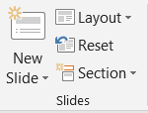

If you want to enter a new slide, the function for this can be found on either the ‘Home’ or the ‘Insert’ tab in the red bar at the top of your screen.

If you click on the word ‘New Slide’ in the grey toolbar at the top of your screen you will get a drop down box with a number of slide layout options.

A screenshot of a social media post

Description generated with very high confidence

I tend to use either:

* Title and content
* Title only
* Blank

There are however others as well.

Which one I choose will depend on what I am wanting the slide to say. If I just want a picture to say what I want to say and not use words, I would choose a blank slide. If I just wanted to create a header, ask a question or convey a single piece of information, I would probably choose a Title only slide. If I wanted to make a number of points, I would most likely choose a Title and Content slide.

Which slide style you choose is important because it determines how PowerPoint’s design ideas are applied.

**Introducing design ideas**

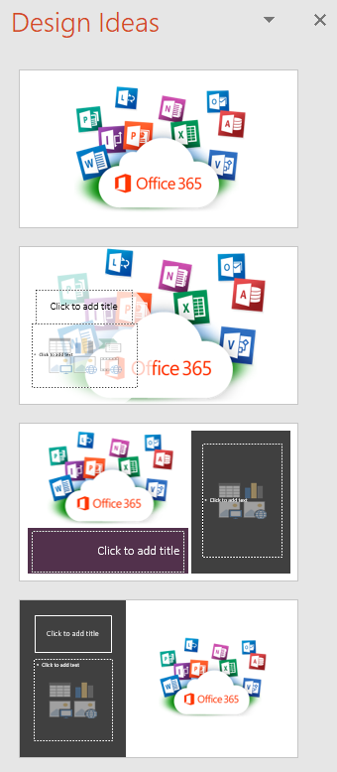

Design ideas are a really great way of professionalising your presentation. It is a feature of PowerPoint in more recent versions of Microsoft Office (notably the Office 365 version) and it is a great addition.

As long as you are connected to the internet), if you put an image or text on to a slide, the newest versions of PowerPoint will offer you a range of design ideas.

These will show up down the right hand side of your screen. Generally you are given 10 to choose from so you will need to scroll down to see them all.

If you select the one that you like the best or is the best fit, PowerPoint will then apply that design to the main slide and you can edit it from there.

|  |  |  |
| --- | --- | --- |
|  |  |  |
|  |  |  |
| This is a design idea generated using a blank slide … note no text box for writing in |  | This is a design idea generated using a Title only slide … there is a text box you can use to convey limited information |
|  |  |  |
|  |  |  |
|  |  |  |
| This design idea was generated by selecting the Title and content style … These are most easily adapted if you want to make multiple points |  |  |

If you click on the ‘New Slide’ **icon** (rather than the words), it will insert a slide with the same layout as the previous slide.



**Ordering slides**

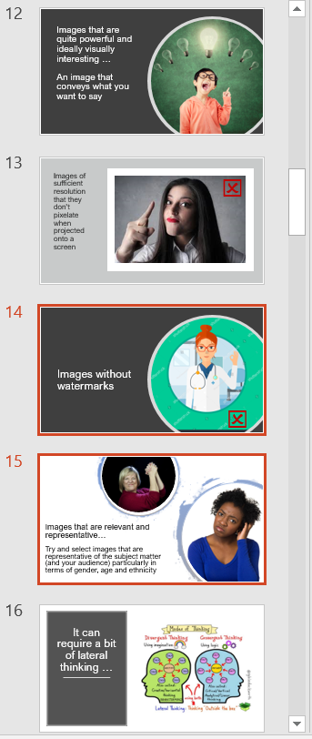

The order your slides are in can be shown as a column down the left hand side of your screen.

*Few tips*

If you select a slide (or indeed several slides) denoted by them then having a red border, then you can drag the selected slides around to reposition them in your presentation.

If you move slides around in this way, be aware that you will lose the ‘design ideas’. For some reason these don’t travel with them.

**Duplicating slides**

A screenshot of a cell phone

Description generated with high confidence

By clicking on the ‘New Slide’ text and then going down you can then click on ‘Duplicate selected slide’ … this gives you a copy of everything on the selected slide, (including (importantly) the ‘Design idea’.

You can move duplicated slides around without losing the design idea.

**Selecting your font**

|  |  |  |
| --- | --- | --- |
|  |  | **A screenshot of a cell phone  Description generated with very high confidence** |

Font selection works exactly the same as in Microsoft Word. It is good to go for a clear and easy to read font such as Arial Nova, Verdana or Tahoma.

I currently like Arial Nova. For headings I tend to go for Point size 36 or above … it varies and depends on how much I am wanting to say, how much space is available and what I think looks best on the slide.

In terms of the main text, I tend to go for Point size 26. This is big enough to be seen clearly when projected but small enough to write full sentences and paragraphs.

Point size 26 is not one of the natural menu options (i.e. 20, 24, 28, 32 …) and therefore needs to be entered manually. Firstly select the text (or text box) you are wanting to apply it to, then click on the existing Point size (highlights blue) and type in 26 to change this.

I also sometimes use Point size 28. It is good if you are only writing a few short sentences, but it is too big really if you are writing several paragraphs on a slide.

Different fonts work better at different sizes so depending on the font you choose, you will have to play around to get the sizes that you think work best.

**Changing your font size (or indeed distance between paragraphs) using the keyboard shortcuts**

First select your text either by highlighting the words or selecting the whole text box.

If you press Ctrl + ] you can make the font size bigger.

If you press Ctrl + [ you can make the font size smaller.

This works in Microsoft Word as well as PowerPoint and is another keyboard shortcut I use a lot.

If you put your cursor in the line between paragraphs, you can alter the size of the gap between them (which basically relates to font size) in the same way.

**Line spacing**

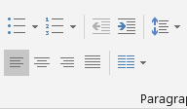

You can change the line spacing with the ‘line spacing’ icon to the very far right of the ‘Paragraph’ menu options (again in the grey task bar at the top of the screen) … blue up and down arrows (🠝🠟)

I tend to set this at 1.0 although 1.15 is a nice spacing if you are writing long documents in Microsoft Word such as Policies & Procedures.

**Creating slide transitions**

A picture containing object

Description generated with high confidence

PowerPoint’s ‘Transitions’ are the way you make one slide change into another. You can have ‘none’ (which is the default) … but equally you can add transitions to make the process a bit more slick and interesting.

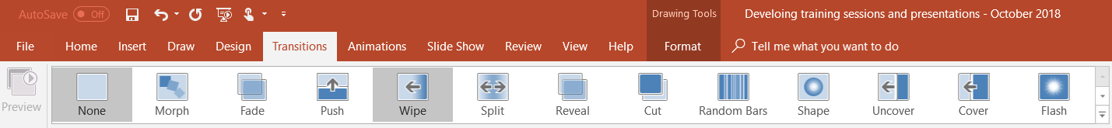

The first thing you need to do when you know what slide(s) you want to apply the transition to is to click on ‘Transitions’ in the red menu bar at the top of your screen.

This reveals a number of transition effects but there are more available. You can either use the scroll bar or click on the 🢗 symbol to reveal all the options.

A screenshot of a cell phone

Description generated with very high confidence

At the moment I am enjoying **shape** from the ‘subtle’ effects menu.



I am also enjoying **ripple** and **page curl** from the ‘exciting’ effects menu.





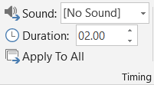

Once you have set your transition, you can use the timing box to extend (or reduce) the duration.

Potentially a smoother transition effect and a slightly longer duration (2 to 2.5 seconds) are easier on the audience than sharper and shorter transitions.

You can also apply the same transition to a number of slides (indeed all of them) by:

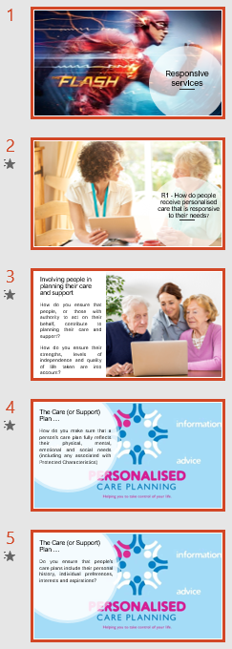

* Clicking on the first slide you want to apply the transition to (which will highlight it in red)
* Holding the shift key down (🡑) click on the last slide you want to apply the transition to (this will result in this and all the slides in between being highlight in red)
* Applying the transition (and duration) that you want.

I would tend to apply the same transition to all the slides in a presentation (apart from the first one).

The only time I might vary this is if I was seeking to create specific contract, i.e. to denote the start of a new section.

**Using PowerPoint ‘animations’**

**A picture containing person

Description generated with very high confidence**

Animations in PowerPoint are effects that you can apply to a selected item (or indeed items) to determine the way they enter, are emphasised or exit your slide. They are probably most often used if you want to stagger the introduction of points when you are giving your presentation.

Select the item(s) you want to animate … text or picture (or both).

Click on ‘Animations’ in the top red bar at the top of your screen.

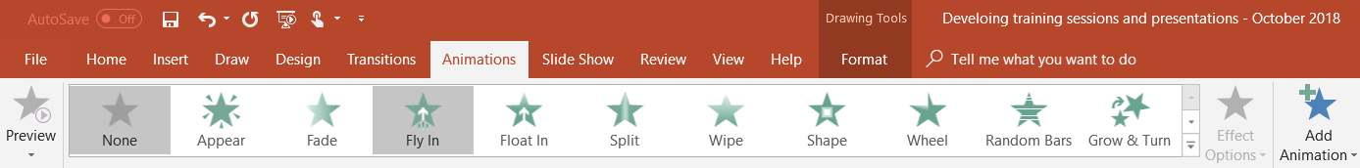

As with ‘Transitions’, you can either use the scroll bar or click on the 🢗 symbol to reveal more options.

A screenshot of a cell phone

Description generated with very high confidence

Have a play … as long as the item you want to animate is selected, clicking on any of these will apply that animation to the item as a ‘preview’.

*A few quick pointers*

I often don’t animate the first point I want to make so it is already ‘up’ when I change the slide.

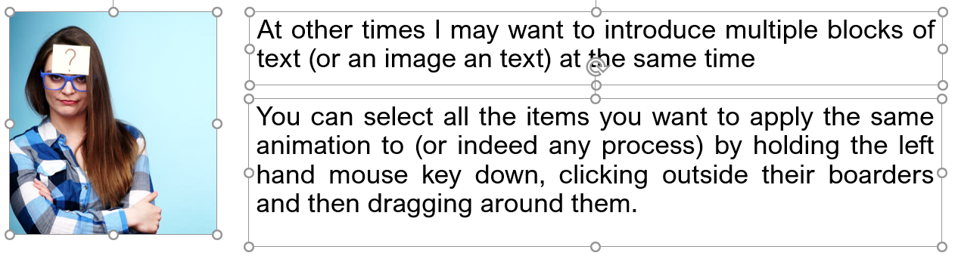

Selected items will then show up like this.

Once you are happy with the animation you want, click on ‘Add Animation’.

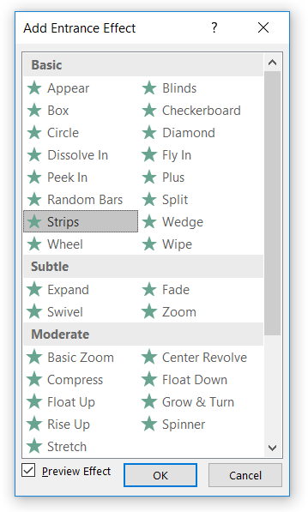

Personally I generally only use animations to enter text or images. I go down to 🟊 ‘More entrance effects’ and select ‘stripes’.

I do this because I like the way it flows the item in smoothly … but (like all aspects of putting together a presentation), what you do is up to you.

|  |  |  |
| --- | --- | --- |
|  | Once I’ve added the animation (by selecting it and clicking OK), I then alter the ‘duration’ from 0.50 seconds to 0.75 or 1.00 seconds. |  |

I then go to effect option and alter the direction in which the animation takes place.

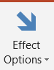

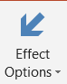

to

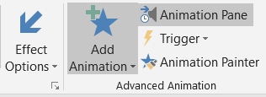

There is an ‘Animations Pane’ which drops down on the right hand side if you click on the icon in the top task bar.

This can be used to preview your animations on that page and if necessary, you can drag and drop them in to different positions to change the order in which they take place.

to

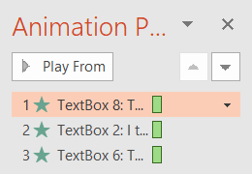

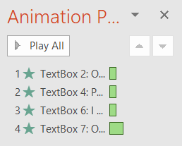

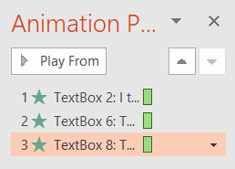

**Removing animations**

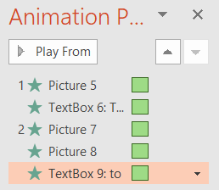

You can either click on the 🢗 symbol next to the animation that you want to remove. This then drops down a list with a ‘remove’ option.

This is one way to do it but I don’t tend to use it.

Instead:

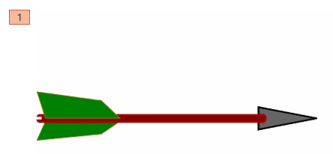

With the animations tab at the top of the screen selected, each animation will have a clear box with a number in it to denote when it takes place in the sequence of animations.

If I want to remove an animation, I click on the box with the number in it and it turns orange. You can then press the delete key and the animation will be removed. NB. This only removes the animated effect, the actual text or image will remain.

**Creating accompanying resources**

Your presentation is aligned to the relevant policy and procedure and hopefully provides a relatively ‘clear and concise’ work through of what you need staff to know / do.



Your accompanying resource is then developed to:

1. Capture the salient points from your presentation in a way that can best serve as a reference resource and ongoing reminder

b) Include a few pertinent questions that can be used to test staff’s understanding of the content.

Your presentation and accompanying resource should be similar but not identical as they are performing slightly different functions. Alongside questions (or exercises) you might want to include a bit more detail in the resource if it is going to serve as an ongoing reference.

**Layout and illustration**

A screenshot of text

Description generated with very high confidence

In terms of layout, you can’t be that sophisticated in Microsoft Word but you can still use pictures to go alongside and illustrate. Your text.

This can be done by either just inserting a picture directly into the body of the document using the insert picture option. This is what I have done below. I have then centred the image.

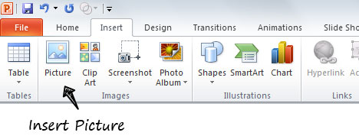

Another option is to insert a table (usually one row and two or three columns but this can vary). This is what I have done in the example given below.

|  |  |
| --- | --- |
| C:\Users\Mik\Pictures\01 - work photo collections\Work relationships 1.jpg | **A person with collar shirt  Description generated with very high confidence** |

Usually I will only put two or three images next to each able in a column as if you do any more then the images become too small. Less is more with this one.

The Third option is to insert a text box which you can do using the ‘Text Box’ option on the insert menu (shown below).

[Grab your reader’s attention with a great quote from the document or use this space to emphasize a key point. To place this text box anywhere on the page, just drag it.]

Inserting a text box is what I have done here. I usually go for the ‘Simple Text Box’ option.

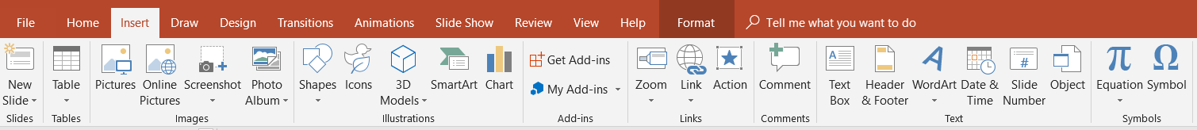

Once you have the text box you can insert the image you want directly into it and then position it where I want it. This should then enable you to write text alongside it (as I am doing here.



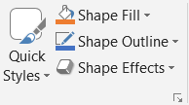

You can also remove the outline from both tables and text boxes. The outline can be removed from a text box by using the ‘Shape Outline’ option and choosing ‘No outline’.

**In terms of the text**

Ideally you want a font that is clear and easy to read. The one used in this document is Arial Nova at Point Size 14 but you can choose whatever you want.



Use your presentation as the basis of your accompanying resource. When writing it try and keep it concise but make sure you elaborate and add additional information where you feel this will be helpful to people using the resource as an ongoing reference.

When you are happy with the content and layout of your final resource, it may be worth saving it as a PDF.



People will need Acrobat Reader to open it but it stops carefully formatted text moving around which it can do sometimes when you print or email the document.